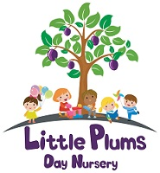
It's fun to play outdoors

Talking tips:

Round and round.
Up and down.
Side to side.
Start at the top.
Holes.
Dots.
Circles.
Lines.

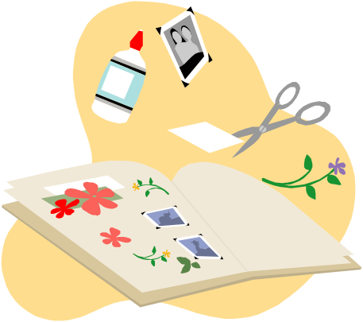
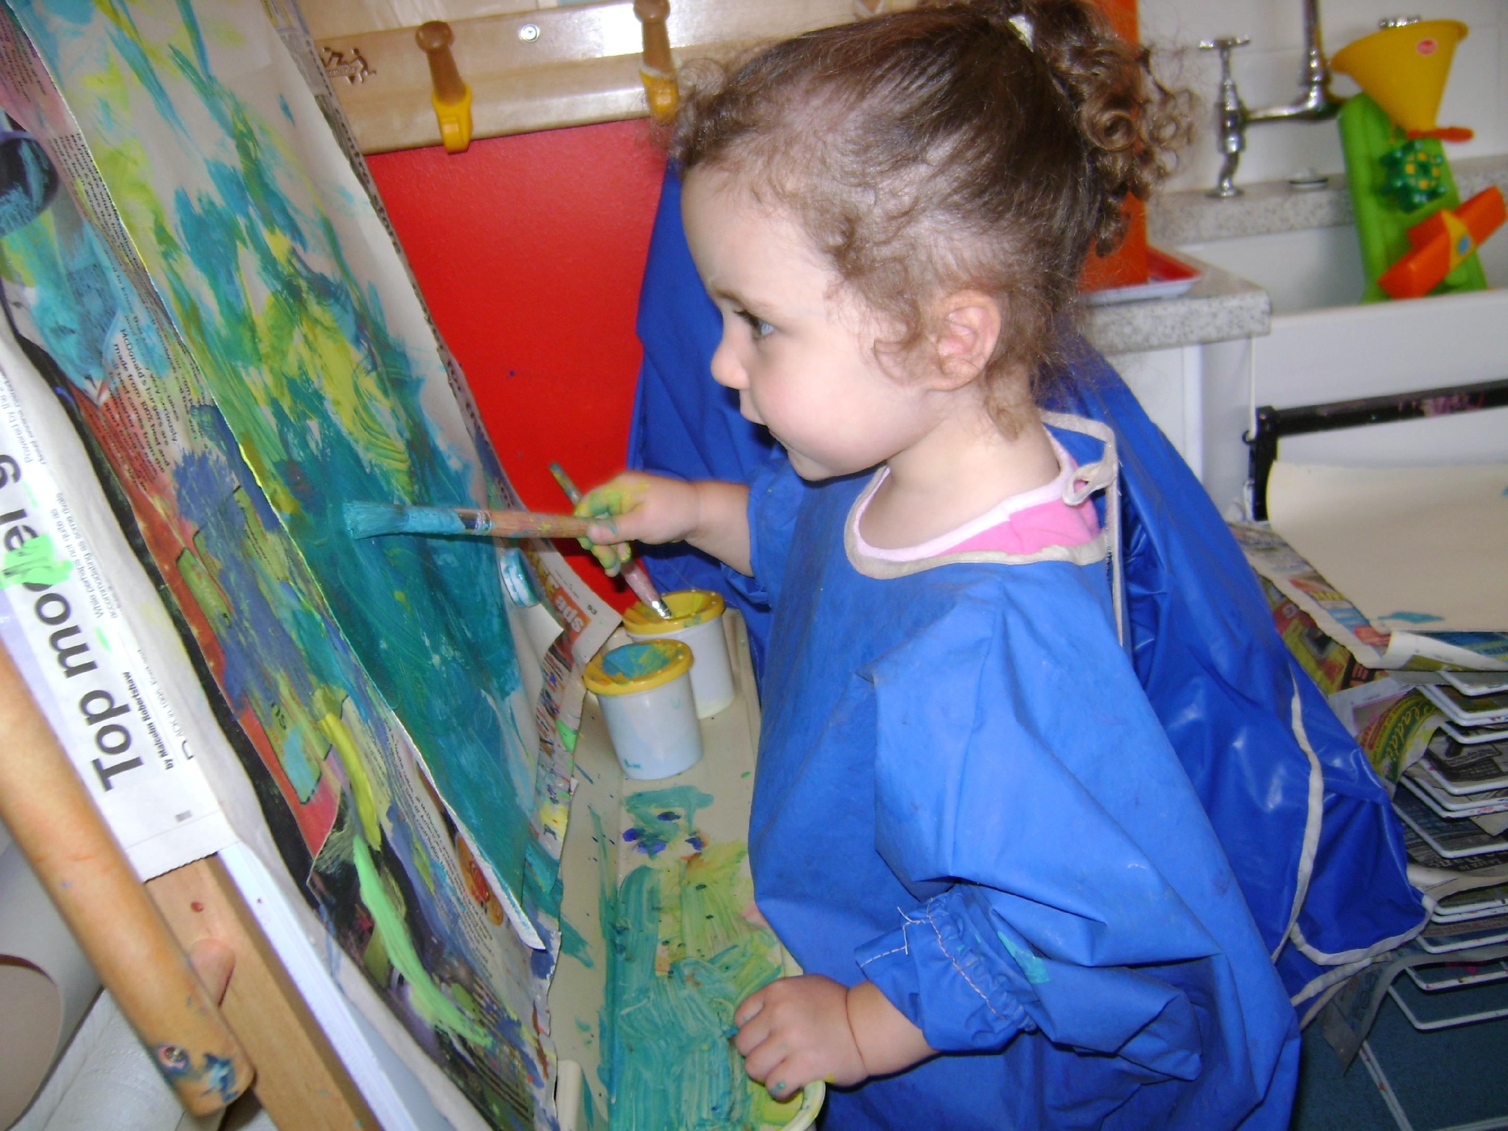
By giving your child chances to make marks will help them begin to develop writing skills.
All marks are good.
Activities you can try:
Draw with sticks in the mud.
Use water in a small bucket with paint brushes to paint the walls and floors.
Use toy cars in flour, sand, mud, to make tracks.
Use chalks or sand stones to draw on the pavement.
Make mud pictures.
Use washing up bottles or spray bottles with water.
Collect natural objects such has grass, leaves, flowers to make sticky pictures.
Make petal potions with petals and water.
Welly printing.

